q

**MARION E. SALLY RESIDENTS CENTER**

**23 CLYDE POTTS DRIVE MORRISTOWN NJ 07960**



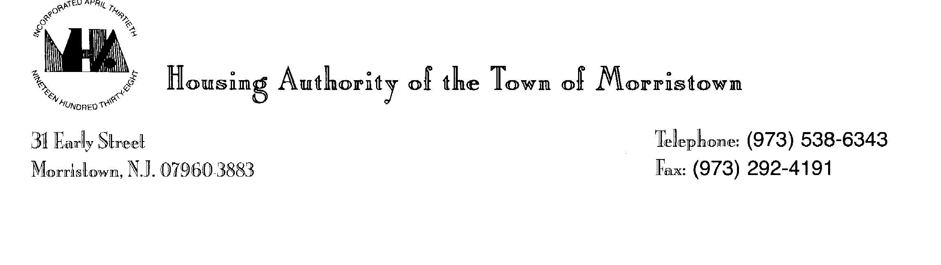

NON-RESIDENT EVENT SPACE RENTAL AGREEMENT

**Date:** ___________________

**Name of Renter Requesting:** ____________________________________________________

**Address:** ________________________**City:** ____________**State:** _______**Zip:** ____________

**Cell #:** ________________________ **Email:** _________________________________________

**Date of Event:** ________________ **Time of Event:** ___________**am/pm to**__________ **am/pm**

**(The time of Event that is listed must include set up and clean up)**

**Total Hours:** _______________ **Room Request:** _____________________________________

**Nature of Event:** _______________________________________________________________

**Approximate # of Guests:** _________________________________ **(Maximum Capacity 200**)

**Rental: $**___________ **Deposit: $**____________

**Total Fees / Deposits Collected: $** __________ **Received By:** ______________ **Date: ________**

**Method of Payment: ______________________________________**

**Renters Signature:** _______________________________________

**Rental Conditions:**

* Morristown Housing Authority -Resident Center is not liable for personal injury, loss, or damage to personal property. The renter accepts full responsibility for any such liability to them, members of their group, or any guests while on the property.
* It is mandated that the renter will make a refundable deposit of the amount stated above. In the event the renter needs to cancel, the deposit will be returned written 30 days of cancellation notice. If any damages have been done the full deposit will not be refunded and will be used for damages.
* Rental Fee is Non- Refundable.
* Payment of the remaining rental fee balance is due; in full; 14 days prior to the scheduled event. Certified Checks and Cashier’s check acceptable modes of payment.
* MHA may supply limited number of tables and chairs.
* Parking on site is not guaranteed. MHA takes no responsibility for guests parking violations, tows or tickets.
* Alcohol and smoking not permitted on site.
* Inappropriate language, physical or verbal abuse not permitted.
* Local noise ordinance must be observed and No loitering permitted.